Ituanose Kemba Mark

Comparative GDP analysis of Canada and China over the period from 2010 to 2019.

INTRODUCTION

This comparative GDP analysis examines the Gross Domestic Product (GDP) of Canada and China over the period from 2010 to 2019. GDP serves as a key indicator of a country's economic performance, reflecting the total value of all goods and services produced within its borders. By comparing the economic trajectories of Canada and China, we aim to discern patterns, trends, and potential implications for these two significant economies.

Countries under Focus:

Canada: Represented in Canadian Dollars (CAD)
China: Initially presented in Chinese Yuan (¥) and converted to Canadian Dollars for comparative analysis (1 Yuan = 0.19 CAD)

Objectives of the Report:
Comparison: to explore the differences and similarities between these two economies, by comparing and analyzing their GDP growth side by side.
Statistical Analysis: to analyze data from both countries for 10 years to know the state of the economic growth, by calculating the mean average, median, mode, and standard deviation we can tell the growth of each economy.
Graphical Illustration: another objective of this report is to give a graphical illustration of the economy of each country, by using charts and graphs to represent data, for this report we would be using bar charts, pie charts, line graphs, and Pareto charts.
Temporal Trends: Exploring the GDP growth trends for both Canada and China from 2010-2019, identifying periods of growth or decline.
Economic Performance: Assess how the GDP of Canada compares to that of China over the specified timeframe.

Note: Diagram and statistical references are shown in the Excel sheets attached along with this file.
Statistical Analysis
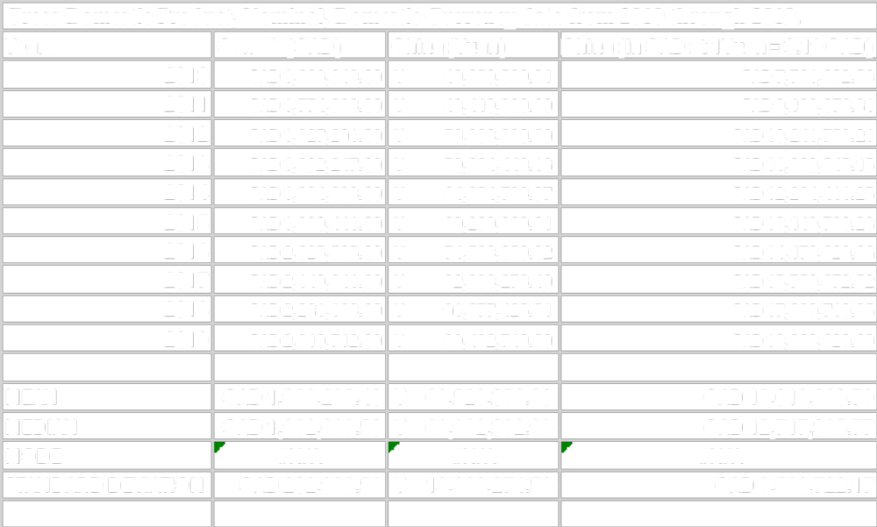

Discussion of Central Tendency Measures:
Mean: The higher mean GDP for China suggests a larger economic output compared to Canada over the ten years with China having an average of CAD 13,019,380.79 and Canada CAD 1,986,295.40, the economy of China is better on average than that of Canada. Difference: China's mean GDP is significantly higher than Canada's, indicating a consistently larger average economic output.
Similarity: Both countries use the mean as a measure of central tendency, providing an average representation of their economic performance.

Median: median values indicate that both countries have comparable middle positions in their GDP distributions. Similarity: Both countries have a median GDP value, suggesting comparable middle positions in their GDP distributions.

Mode: The absence of a mode in both countries signifies a lack of concentration of GDP values around a specific figure, pointing to a relatively uniform distribution. Similarity: Both countries exhibit no mode.

Standard Deviation: The standard deviation provides a measure of the dispersion of GDP data points around the mean, offering insights into the stability and volatility of each country's economy. In the case of Canada, with a standard deviation of CAD 202,933.59, the relatively smaller magnitude suggests a more stable or slow economic performance over the ten years. This indicates that the GDP values are closely clustered around the mean, reflecting a consistent growth pattern with less variability. Conversely, for China, the larger standard deviation of CAD 3,589,722.17 signifies greater variability in GDP values, indicating a wider range of economic outputs. This higher volatility may be attributed to the dynamic nature of China's growing economy, influenced by various internal and external factors. Overall, the standard deviations provide a quantitative measure of economic stability, with Canada exhibiting more consistency and China displaying greater fluctuations in its GDP values.
Difference: China's higher standard deviation suggests more variability in GDP values, indicating a larger range of economic outputs compared to the more stable Canadian economy.
Similarity: Both countries use standard deviation to measure the dispersion of data points around the mean.
Conclusion:
The central tendency measures provide a comprehensive view of the GDP data for Canada and China. While the mean and median reflect the average and middle points, the lack of mode suggests a relatively uniform distribution. The standard deviation indicates the variability around the mean, with China's economy showing greater fluctuations. These measures highlight the nuanced differences and similarities in the economic performances of the two countries over the specified period.

Graphical Analysis:
Pie Chart:
The pie charts for Canada and China show a visual representation of the changing proportion of GDP for each year. In Canada, there is a stable growth rate with a few years having similar proportions which signifies stability from the year 2013-16 It is seen that the growth of Canada’s economy Is 10%.
Canada's pie charts suggest a stable and consistent economic structure.
In contrast, China's charts show a more dynamic landscape, with almost every year growing and changing except for the year 2013-14 when it experienced a stable growth of 9%.
From the chart, we can see that Canada’s economy started well before China leading with 8% but couldn’t keep up the growth with China leading 15% in 2019, showing the growth ratio between both countries.

Both countries exhibit an increase in the proportion of GDP, especially in the later years. However, China's charts portray a more sustained upward trajectory, reflecting its higher growth rates. The analysis of these charts provides a nuanced understanding of the factors shaping the proportion of GDP in each country, contributing to a comprehensive view of their economic dynamics.
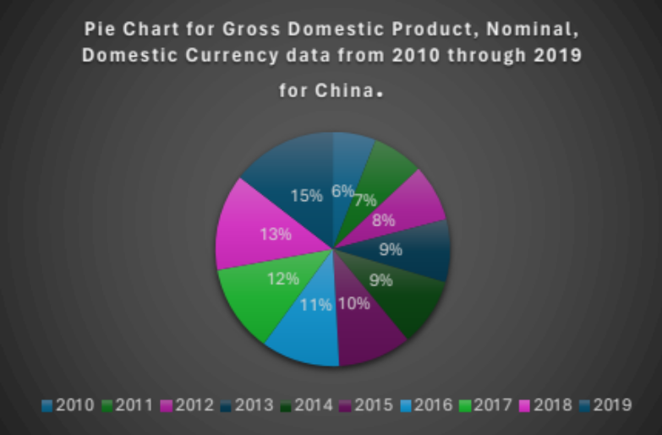
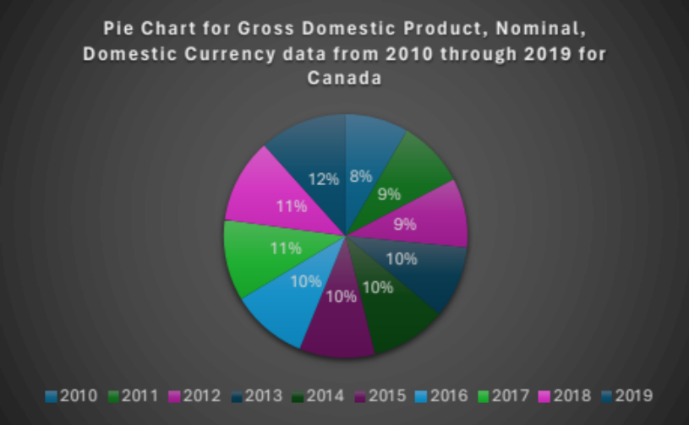

Line Graph:
The line graph depicting the GDP trends for Canada and China over the ten years offers insights into the growth trajectories of both economies. It showcases overall growth trends in both countries as an upward slope indicates robust economic growth in the country China as opposed to the steady economy of Canada. Also, the lines assess the relative growth rates between Canada and China where China’s growth is progressive Canada suffered a decline in 2015 where the GDP dropped. Through the analysis of slopes, the graph provides a comprehensive view of the economic dynamics, allowing for insights into the factors affecting the growth of both countries. This analysis contributes to a nuanced understanding of how each nation's economy evolved during the specified period.
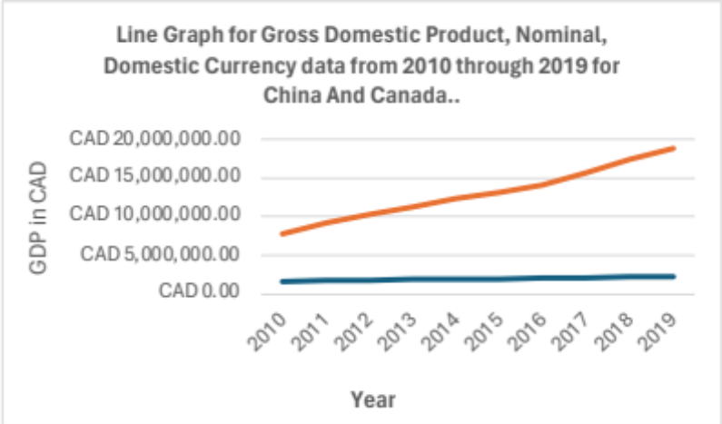

Bar Chart:
The bar chart provides a visual representation for comparing the annual GDP between Canada and China. Its analysis unveils yearly economic disparities, impacts, and the relative economic positions of the two nations. This in-depth understanding aids in drawing comprehensive conclusions about the economic dynamics and performance of Canada and China over the specified period, in which China’s economy outperforms Canada. The bar charts also show the yearly disparities, trends over time, relative economic size, and economic preferences, which China seems to be leading.
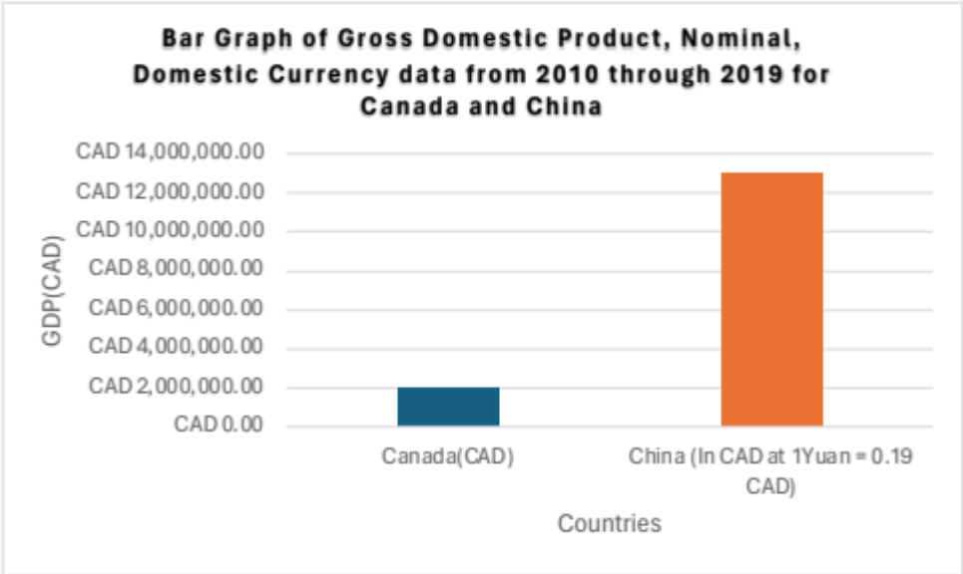

Pareto Chart:
The Pareto chart identifies the most significant years for GDP changes according to the 80/20 rule. This highlights the years contributing the most to the overall economic changes in both countries. For both Canada and China, the top years contributing to 80% of the GDP are the most recent years (2019, 2018, 2017, 2016, and 2015).
This suggests that a significant portion of each country's GDP is concentrated in these years.
The Pareto analysis helps identify the key contributors to the overall economic output, allowing for a focused understanding of the most influential periods.
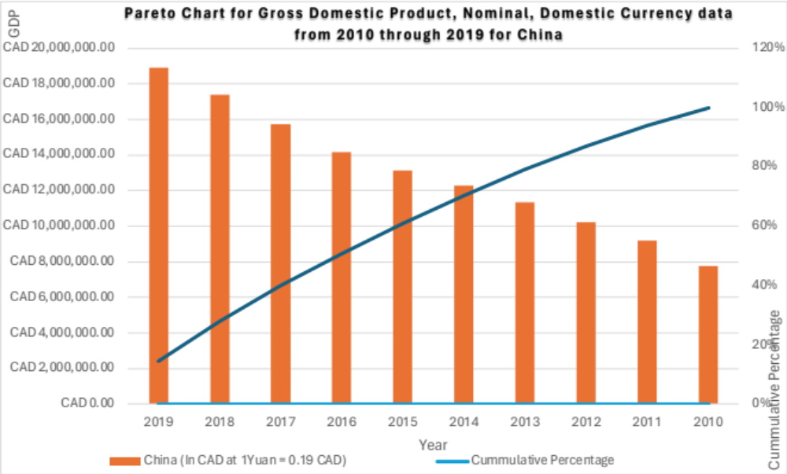
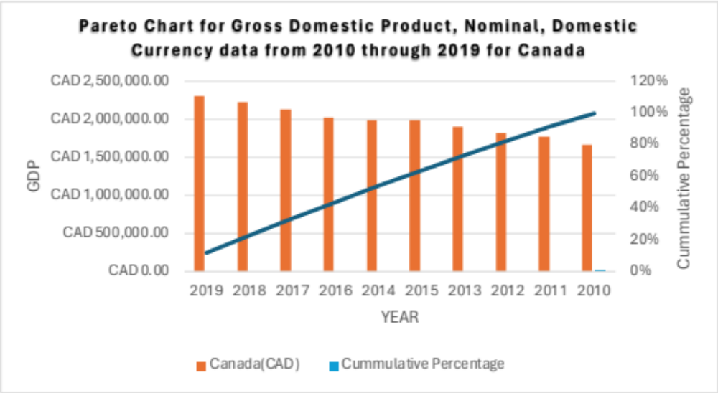
Conclusion:

In conclusion, the statistical analysis and graphical representations provide an understanding of the economic scenarios in Canada and China. While both countries exhibit similar central tendencies in terms of median GDP, the graphical analysis can reveal patterns and trends that go beyond numerical measures. Canada's economy appears relatively stable with moderate variability, while China's larger mean GDP and higher standard deviation suggest a more dynamic economic landscape. Further detailed analysis of the graphs in the full report would unveil specific patterns, outliers, and potential factors influencing the economic performances of these two nations.
REFERENCES
International Monetary Fund. (n.d.). Gross Domestic Product and Components selected indicators: Canada and China. International Financial Statistics (IFS)

